SIMATS ENGINEERING
ASSESSMENT TOOL 1
Course Code | CSA51
Course Name | Cryptography and Network Security
Course Outcome (CO2) | Analyze Public Key crypto system strategies using RSA and Key Exchange for Encryption algorithm to strengthen information security. (BL4, BL5)
Analytical Problem Solving | 40%
Total Marks | 50
Annexure A – Code of Conduct
I M .Mokshith Reddy - 192372373 certify that this submission is my original work and that I have adhered to the guidelines specified for this assessment.
I understand that any violation of academic integrity rules will result in disciplinary action.
Signature of the student: M. Mokshith Reddy

1. RSA Encryption Analysis
Given: p = 11, q = 13

a. Compute n and φ(n)
n = p × q = 11 × 13 = 143
φ(n) = (p − 1)(q − 1) = 10 × 12 = 120

b. Choose e = 7 and find the private key d
Check gcd(e, φ(n)) = gcd(7, 120) = 1 → e = 7 is a valid public exponent.
Find d such that e × d ≡ 1 (mod φ(n)), i.e. 7d ≡ 1 (mod 120):
7 × 103 = 721 = (6 × 120) + 1 → d = 103
Public key = (e = 7, n = 143) Private key = (d = 103, n = 143)

c. Encrypt the message M = 9
C = M^e mod n = 9^7 mod 143
Step | Computation | Result mod 143
9^2 | 81 | 81
9^3 | 81 × 9 = 729 | 14
9^4 | 14 × 9 = 126 | 126
9^5 | 126 × 9 = 1134 | 133
9^6 | 133 × 9 = 1197 | 53
9^7 | 53 × 9 = 477 | 48
Ciphertext C = 48

d. Decrypt the ciphertext and verify the result
M = C^d mod n = 48^103 mod 143
Using square-and-multiply (103 = 64 + 32 + 4 + 2 + 1 in binary 1100111):
Power of 48 (mod 143) | Value
48^1 | 48
48^2 | 16
48^4 | 113
48^8 | 42
48^16 | 48
48^32 | 16
48^64 | 113
48^103 = 48^64 × 48^32 × 48^4 × 48^2 × 48^1 mod 143 = 113 × 16 × 113 × 16 × 48 mod 143 = 9
Recovered plaintext M = 9, which matches the original message. Decryption is verified.
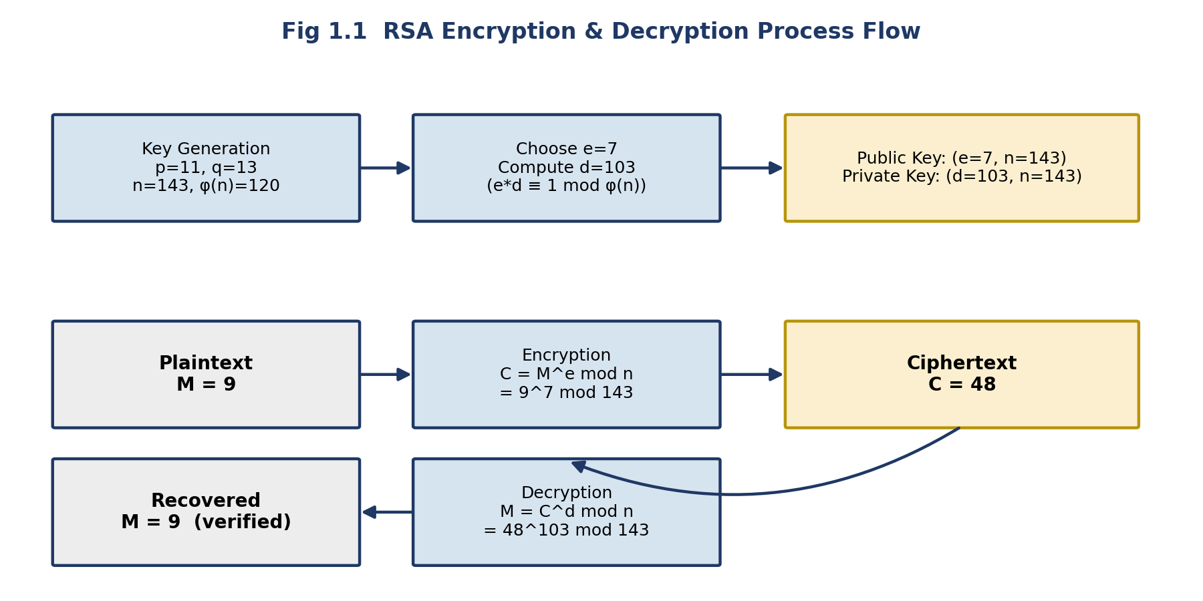
Fig 1.1: RSA key generation, encryption and decryption flow

e. Analyze how changing e affects security
- A very small public exponent (e.g. e = 3) speeds up encryption but is dangerous without proper padding: if the same message is sent to several recipients with different moduli, Coppersmith's / Håstad's broadcast attack can recover the plaintext without factoring n.
- Small e also makes messages with small M vulnerable, since M^e may not even wrap around n, allowing direct computation of the eth root.
- A larger e increases resistance to such low-exponent attacks but increases encryption computation cost; decryption cost depends on d, which is typically large regardless of e.
- e must always satisfy gcd(e, φ(n)) = 1; common practical choices are e = 65537 (2^16+1), which balances security and performance.
- Overall, the security of RSA depends far more on the size of n (and secrecy/randomness of p, q) than on the specific value of e, provided e is not trivially small and proper OAEP padding is used.

2. Block Cipher Mode Evaluation
Given: Plaintext blocks P = [1010, 1010, 1111, 1010], Key K = 1100, IV = 0000
For illustration, the encryption function E(X) is modeled as a bitwise XOR of the block with the key: E(X) = X ⊕ K (the same principle of block-wise transformation used in real ciphers such as DES/AES, simplified for a 4-bit block).

a. Encrypt using ECB and CBC modes
ECB Mode — each block is encrypted independently:
Block | Plaintext | Operation | Ciphertext
1 | 1010 | 1010 ⊕ 1100 | 0110
2 | 1010 | 1010 ⊕ 1100 | 0110
3 | 1111 | 1111 ⊕ 1100 | 0011
4 | 1010 | 1010 ⊕ 1100 | 0110
CBC Mode — each block is XORed with the previous ciphertext (C0 = IV) before encryption:
Block | Plaintext | XOR with prev. C | Intermediate | Ciphertext
1 | 1010 | 1010 ⊕ 0000 (IV) | 1010 | 0110
2 | 1010 | 1010 ⊕ 0110 | 1100 | 0000
3 | 1111 | 1111 ⊕ 0000 | 1111 | 0011
4 | 1010 | 1010 ⊕ 0011 | 1001 | 0101
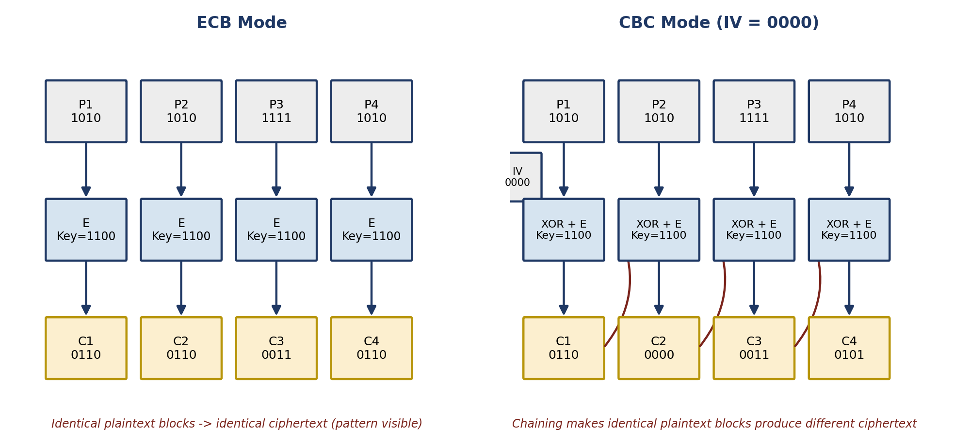
Fig 2.1: ECB vs CBC encryption of repeated plaintext blocks

b. Compare the ciphertext outputs
Block | Plaintext | ECB Ciphertext | CBC Ciphertext
1 | 1010 | 0110 | 0110
2 | 1010 | 0110 | 0000
3 | 1111 | 0011 | 0011
4 | 1010 | 0110 | 0101
In ECB, blocks 1, 2 and 4 (all with plaintext 1010) all map to the same ciphertext 0110, directly revealing that the underlying plaintext blocks are identical. In CBC, the same three plaintext blocks produce three different ciphertexts (0110, 0000, 0101), so no repetition is visible in the ciphertext.

c. Analyze which mode hides patterns better and explain why
CBC mode hides patterns significantly better than ECB.
- ECB encrypts every block independently using only the key, so identical plaintext blocks always produce identical ciphertext blocks. This leaks structural information about the plaintext (the classic example is the “ECB penguin” image, where the outline remains visible after encryption).
- CBC “chains” each block by XOR-ing it with the previous ciphertext block before encryption. Because the input to the encryption step is different for every block (even when the plaintext repeats), the resulting ciphertext blocks differ.
- This chaining also means that CBC ciphertext depends on the position of a block and on all preceding blocks, so an attacker cannot infer repeated plaintext by comparing ciphertext blocks.
- The trade-off is that CBC is inherently sequential (each block depends on the previous one), and a bit error in one ciphertext block affects the decryption of that block and the next, whereas ECB blocks can be processed independently and in parallel but at the cost of pattern leakage.

3. DES vs 3-DES vs Blowfish Performance Study
Algorithm | Key Size | Time per Block
DES | 56 bits | 2 ms
3-DES | 168 bits | 6 ms
Blowfish | 128 bits | 1 ms

i. Total encryption time for 1000 blocks
Algorithm | Calculation | Total Time
DES | 1000 × 2 ms | 2000 ms = 2 s
3-DES | 1000 × 6 ms | 6000 ms = 6 s
Blowfish | 1000 × 1 ms | 1000 ms = 1 s
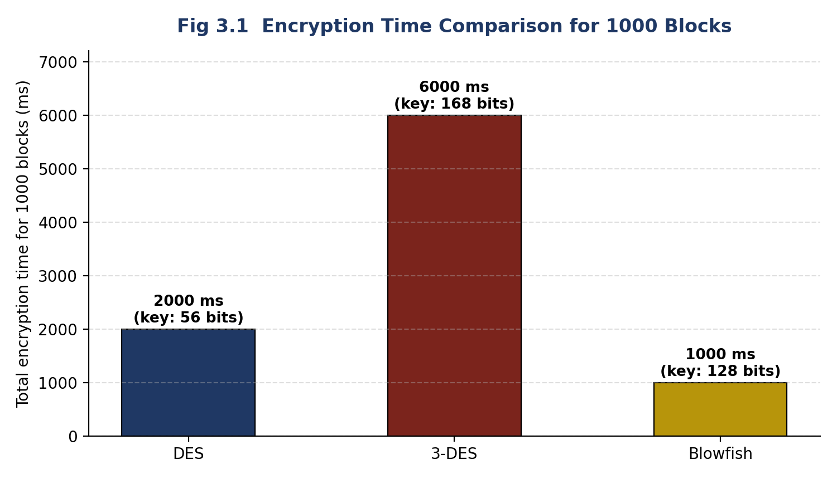
Fig 3.1: Total encryption time for 1000 blocks across DES, 3-DES and Blowfish

ii. Trade-offs between security and performance
- DES (56-bit key, 2 s total): fastest of the two legacy options, but its small key space is vulnerable to brute-force search with modern hardware; DES alone is now considered cryptographically weak/broken for security-sensitive use.
- 3-DES (168-bit key, 6 s total): applies DES three times, giving an effective security level of roughly 112 bits against known attacks. This is much stronger than DES but three times slower, since it repeats the DES algorithm three times per block.
- Blowfish (128-bit key, 1 s total): fastest of all three and provides strong security with a 128-bit key and a large number of rounds (16), making it well suited to applications needing both speed and security.
- There is a clear trade-off: 3-DES sacrifices speed for higher assurance, while DES sacrifices security for speed. Blowfish achieves a favorable balance — strong key length with the lowest computation time in this data set.

iii. Recommendation for secure real-time communication
Blowfish is the most suitable choice among the three for secure real-time communication.
It offers the lowest per-block processing time (1 ms), which is critical for real-time systems such as VoIP or video conferencing where latency directly affects user experience, while still providing a 128-bit key size that resists brute-force attacks far better than DES. 3-DES, though more secure, is too slow (6× the time of Blowfish) for strict real-time constraints, and DES no longer offers adequate security for sensitive real-time data despite its speed.

4. Diffie-Hellman Key Exchange Analysis
Given: p = 23, g = 5, User A private key a = 6, User B private key b = 15

d. Compute public keys for A and B
A_public = g^a mod p = 5^6 mod 23
Step | Computation | Result
5^2 mod 23 | 25 mod 23 | 2
5^3 mod 23 | 2 × 5 = 10 | 10
5^6 mod 23 | 10^2 = 100 mod 23 | 8
A_public = 8
B_public = g^b mod p = 5^15 mod 23
Step | Computation | Result
5^2, 5^4, 5^8 mod 23 | 2, 4, 16 | 2, 4, 16
5^15 = 5^8·5^4·5^2·5^1 | 16×4×2×5 mod 23 | 19
B_public = 19

e. Compute the shared secret key
A computes: S = B_public^a mod p = 19^6 mod 23 = 2
B computes: S = A_public^b mod p = 8^15 mod 23 = 2
Both users independently arrive at the same shared secret key S = 2, without ever transmitting their private keys over the channel.
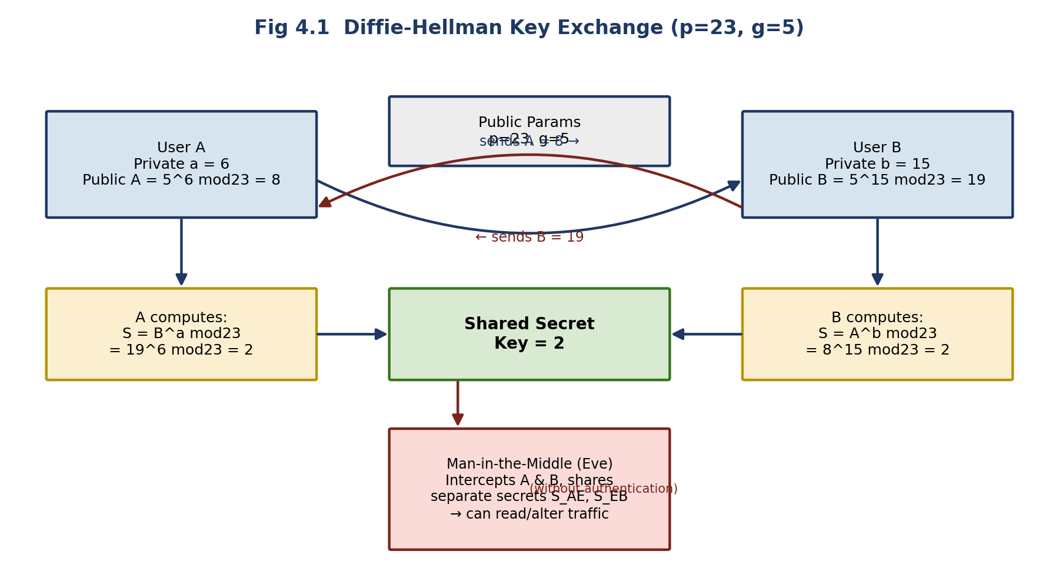
Fig 4.1: Diffie-Hellman key exchange and Man-in-the-Middle vulnerability

f. Demonstrate how a Man-in-the-Middle attacker could alter the exchange
- Diffie-Hellman, as shown above, exchanges only public values (A_public, B_public) but does not authenticate who sent them.
- An attacker Eve can intercept A's public value (8) before it reaches B, and instead send B her own public value, say E_A = 5^x mod 23 for some private x she chooses.
- Similarly, Eve intercepts B's public value (19) and sends A a different value E_B = 5^y mod 23.
- A now computes a shared secret with Eve (thinking it is shared with B), and B computes a different shared secret with Eve (thinking it is shared with A). Eve knows both secrets and can decrypt, read, modify, and re-encrypt every message passing between A and B, while both parties believe they are communicating directly and securely with each other.

g. Suggest a secure method to prevent the attack
- Use Authenticated Diffie-Hellman, such as the Station-to-Station (STS) protocol, where each party digitally signs their public value so the other side can verify it genuinely came from them.
- Bind public keys to verified identities using a Public Key Infrastructure (PKI) with digital certificates issued by a trusted Certificate Authority (CA).
- Deploy the exchange within an authenticated protocol such as TLS, which combines Diffie-Hellman (or ECDHE) with certificate-based authentication to prevent MITM attacks.
- Additionally, out-of-band verification of key fingerprints (e.g. comparing hashes over a separate trusted channel) can detect tampering.

5. ECC vs RSA Comparison
Given: RSA key size = 1024 bits, ECC key size = 160 bits (equivalent security), Device = resource-constrained IoT device

Equivalent security key-size reference
Symmetric Security Level | RSA Key Size | ECC Key Size
80-bit | 1024 bits | 160 bits
112-bit | 2048 bits | 224 bits
128-bit | 3072 bits | 256 bits

d. Computational cost for both systems
- RSA operations (encryption, decryption, signing) rely on modular exponentiation with numbers as large as the key size (1024 bits), which is computationally expensive, particularly the private-key operation (decryption/signing) that uses the full-size exponent d.
- ECC relies on elliptic-curve point multiplication over a much smaller field (160 bits) to achieve the same security level. For equivalent security, ECC operations require significantly fewer bit-operations than RSA's modular exponentiation.
- As a result, ECC key generation, encryption, and especially decryption/signing are computationally lighter than RSA at an equivalent security level, though ECC point operations are individually more complex per-bit than modular multiplication — the net effect still favors ECC due to the much smaller operand size.

e. Which consumes less power and memory
- Memory: A 160-bit ECC key occupies roughly 1/6th the storage of a 1024-bit RSA key, reducing RAM/flash usage for key storage, smaller certificates, and less bandwidth consumed during key exchange — all valuable on memory-constrained IoT hardware.
- Power: Because ECC needs far fewer computational cycles to perform equivalent-strength operations, it draws less energy per operation, which directly extends battery life on constrained/battery-powered IoT devices.
- ECC therefore consumes both less power and less memory than RSA for an equivalent level of security.
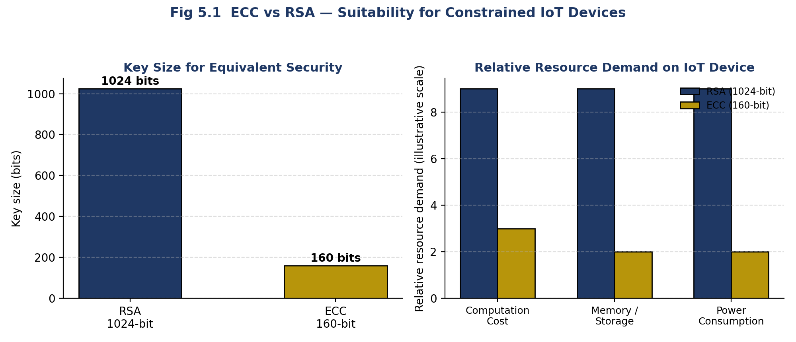
Fig 5.1: Key-size comparison and relative resource demand of RSA vs ECC on a constrained device

f. Justification: which cryptosystem is better for the given scenario
ECC (Elliptic Curve Cryptography) is the better choice for the IoT scenario described.
IoT devices are typically constrained in processing power, memory, storage, and battery capacity. ECC achieves the same security level as RSA with a much smaller key size (160-bit ECC ≈ 1024-bit RSA), which directly translates into faster computations, lower memory footprint, reduced bandwidth for exchanging keys/certificates, and lower energy consumption. These characteristics align precisely with the operational limits of IoT hardware, whereas RSA's larger keys and heavier modular-exponentiation operations would strain processing time and drain battery life faster. For this reason, ECC is recommended over RSA for securing communication on the given IoT device.
— End of Assessment —

